

Post Graduate Certification Program in DevOps

PROJECT1- SOLUTION

Building a CI/CD Pipeline for a Retail Company

Solution-:

Step-1: Pushed project to github repository from local system.

Step-2: Jenkins Setup

Step 3-: Creating Jenkins pipeline and doing maven build

Step-:3 Dockerfile Creation, docker build and image pushed to docker hub repository using ansible.

Step 4-: Setting Kubenetes cluster pods

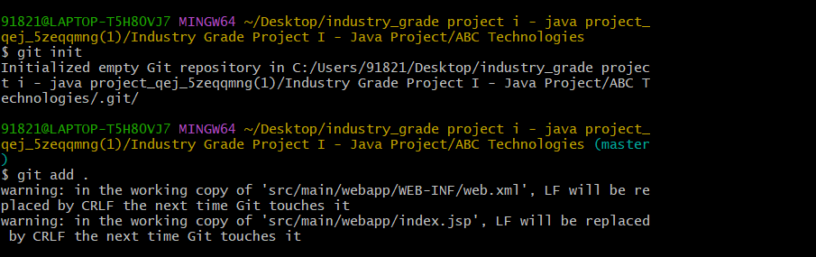

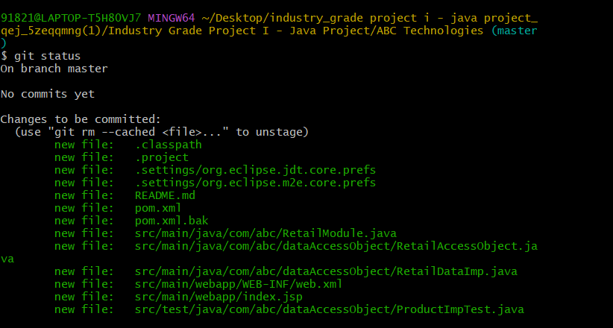



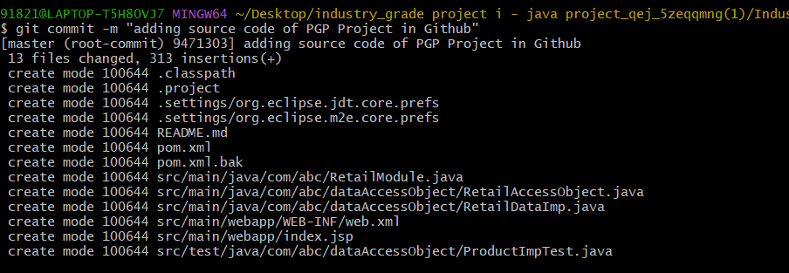

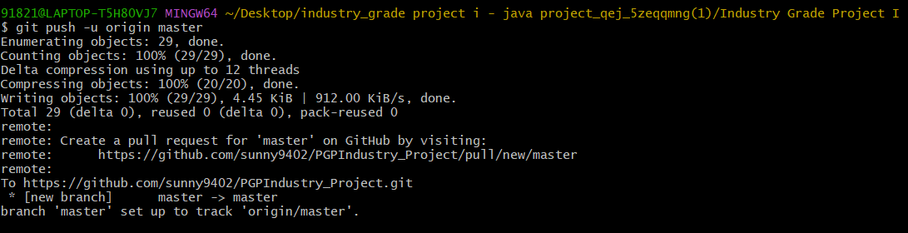

Step-:2  
  
Setting Jenkins and

